**System Design Specification**

# DOCUMENT MANAGEMENT

## 1.1Contributors

|  |  |
| --- | --- |
| **Role** | **Name** |
| Project creator | Jerry |
| Collaborator | Harry |

## 1.2Version Control

|  |  |  |  |  |
| --- | --- | --- | --- | --- |
| **Date** | **Version** | **Author** | **Section** | **Amendment** |
|  | 0.1 | All | All | Prototype |
|  |  |  |  |  |
|  |  |  |  |  |

# OVERVIEW

USER MANAGEMENT SYSTEM enables users to donate to the charity organisation they love. This SDS details the simple prototype which allows users to create their account and posted their own personal information. They can upvote the organization they love or trust and make a donation. Later features include sending chat messages from user to organization, including images and videos, history of donation of each user and statistical diagrams that visualizes data on different criterion.

The project will be developed and deployed web-based only.

# DEVELOPMENT TOOLS AND STANDARDS

## 3.1 Development tools (MERN stack)

Programming language: Javascript

Front-end framework: React, Redux

Back-end framework: Express & NodeJS

Database: MongoDB Atlas

Payment method: Stripe

Realtime chat: Socket.io

Statistical diagrams: Chart.js

Deployment Server: Heroku

JSON API backend documentation: Swagger

Logger: morgan

# Project File Structure (Prototype)

Review source code

# USER INTERFACE (Prototype)

## 5.1 User Profile Page

## /profile

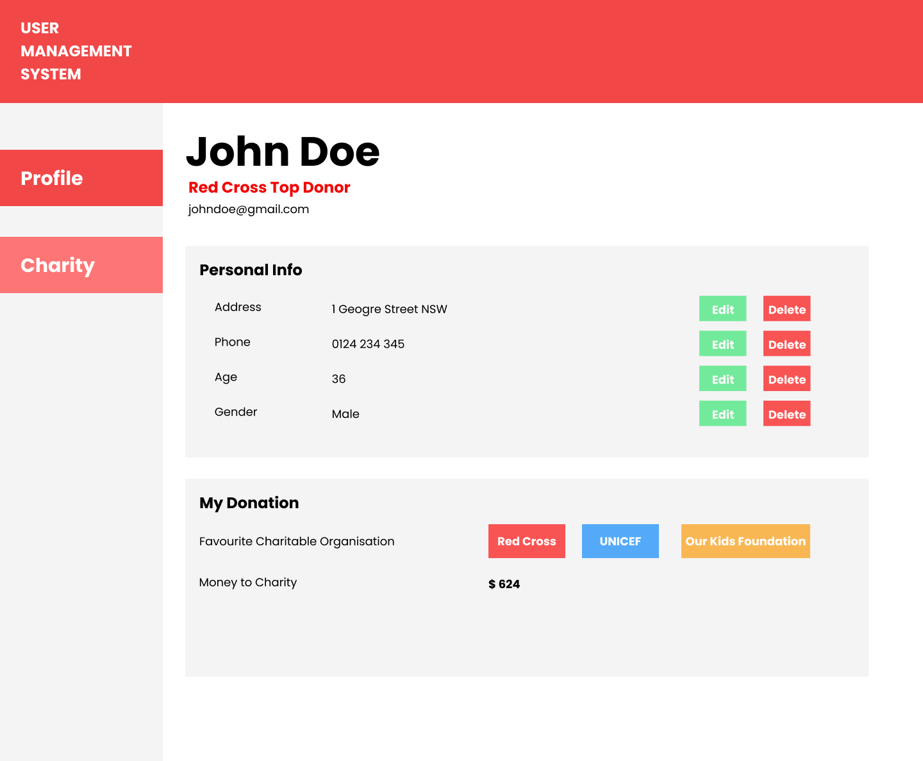

## 5.2 Organisations Page

## /organisations

## 

## 5.3 Organisation Page

## /organization/:id

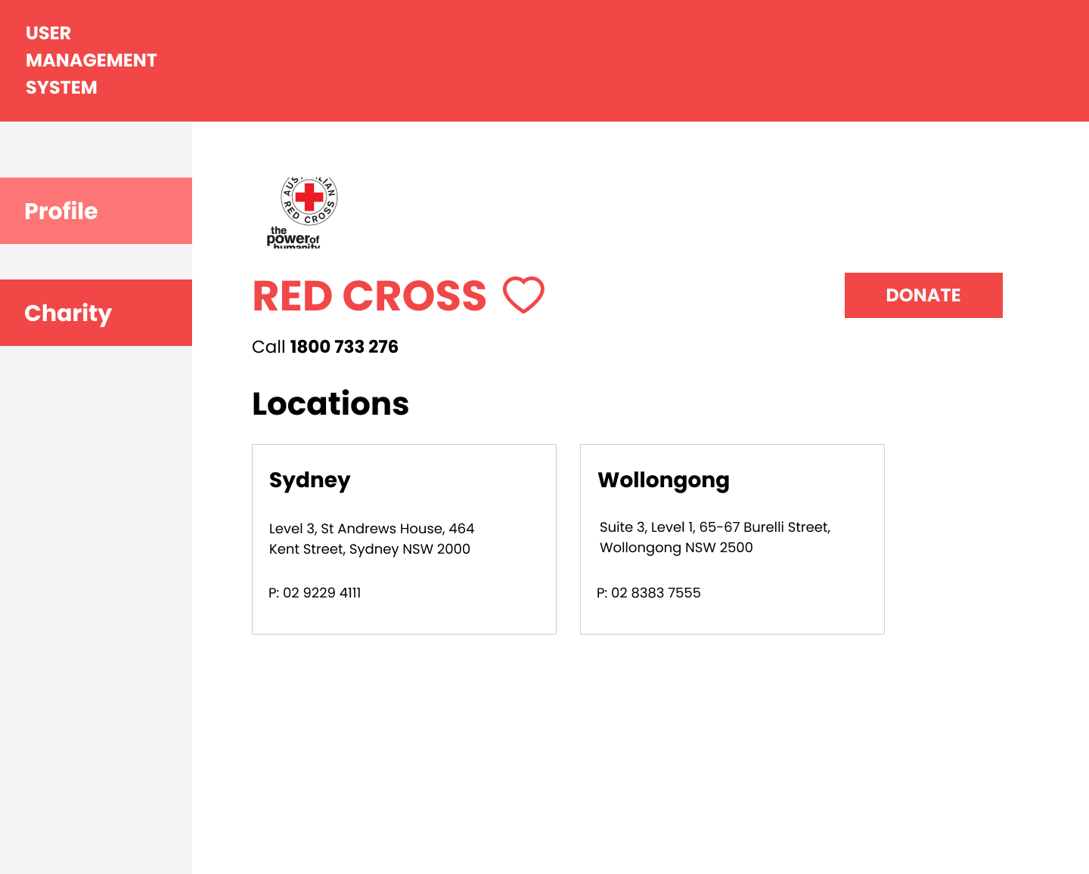

## 5.4 Transition Page

## /organisation/:id/checkout

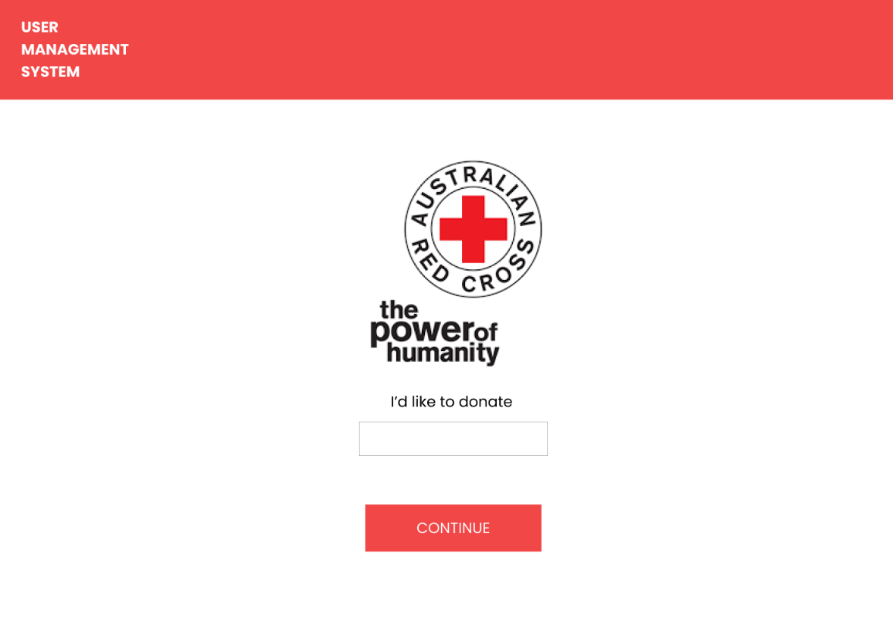

## 5.4 Donation Page

## /organisation/:id/donate

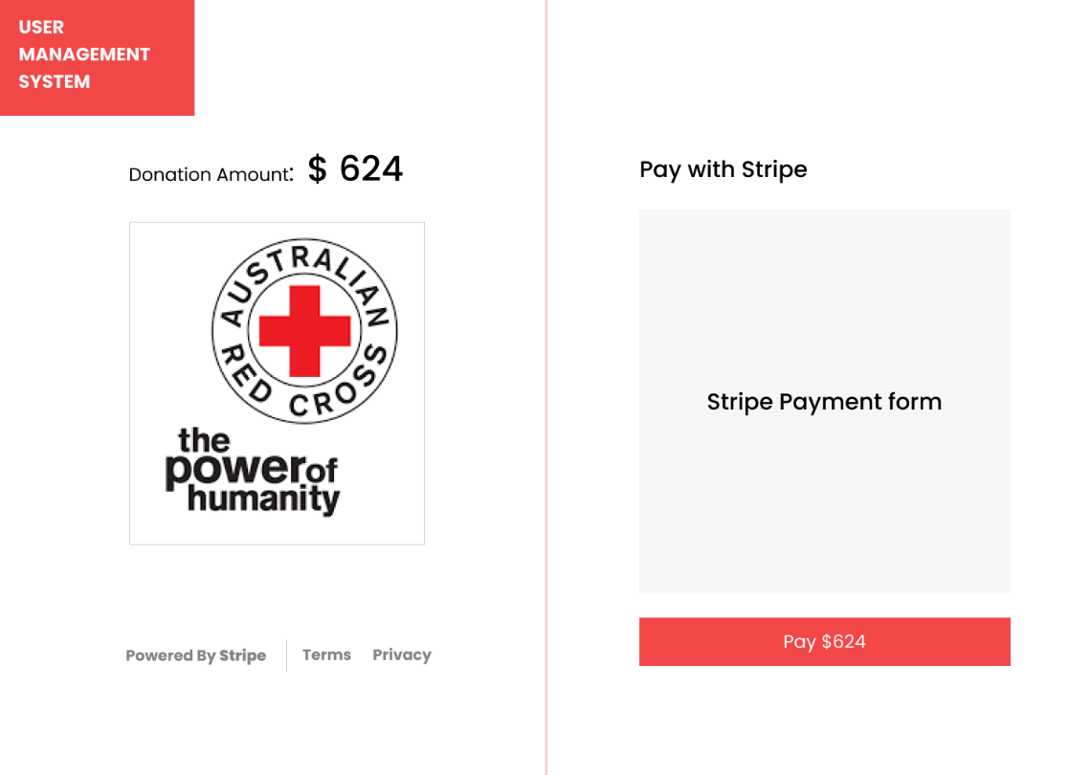

# APPLICATION SECURITY

CORS, Jwt, Role Authentication, Session, csrf attack. (Not available for the current prototype)

# 7.DATABASE DESIGN

# Overview